**Virtual Machine Installation Instructions**

1. Install VirtualBox from the website: [www.virtualbox.org](http://www.virtualbox.org)

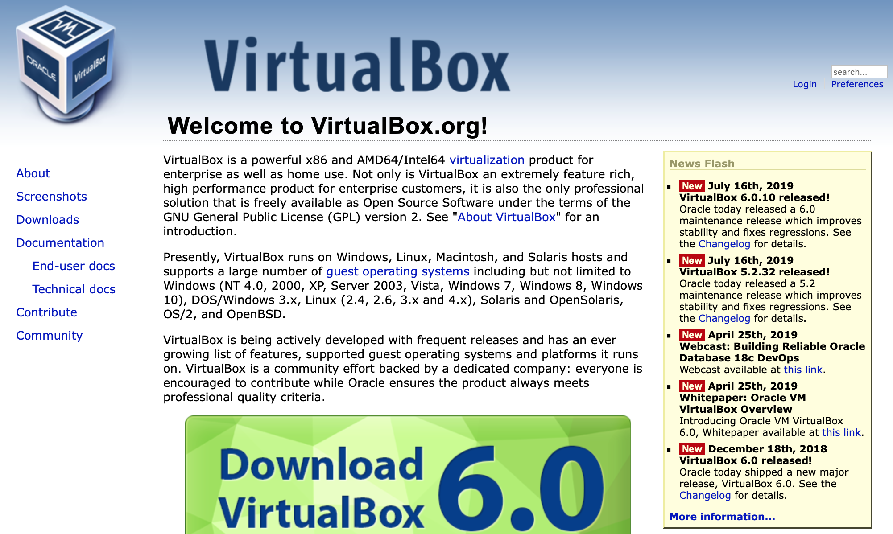

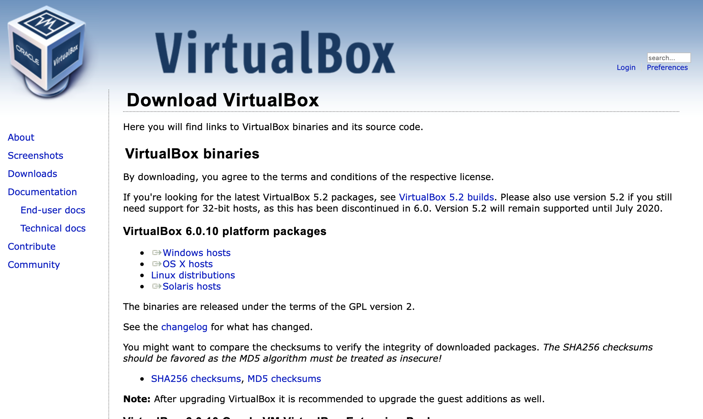

Download the appropriate version. If your computer is running Windows, download the “Windows hosts.” If your computer is Mac, download the “OS X hosts”

1. Install VirtualBox by double clicking the file you downloaded and following its instructions.
2. Get the virtual machine file (filename: math487.ova) from my flash drive. Or you can also download it from my Dropbox following the link:

<https://www.dropbox.com/s/p0vmgop275r1rvo/math487.ova?dl=0>

1. Open VirtualBox you just installed, and click import

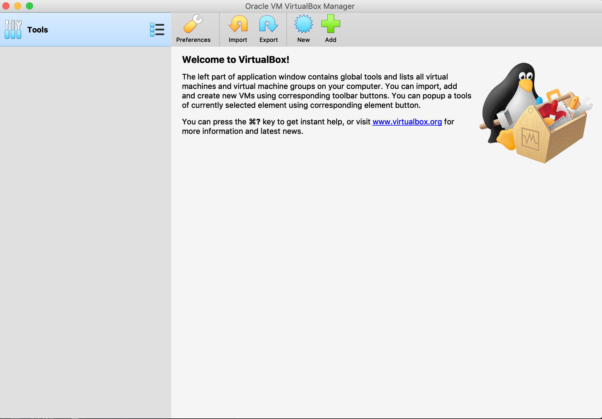

Next you see this and click the folder icon:

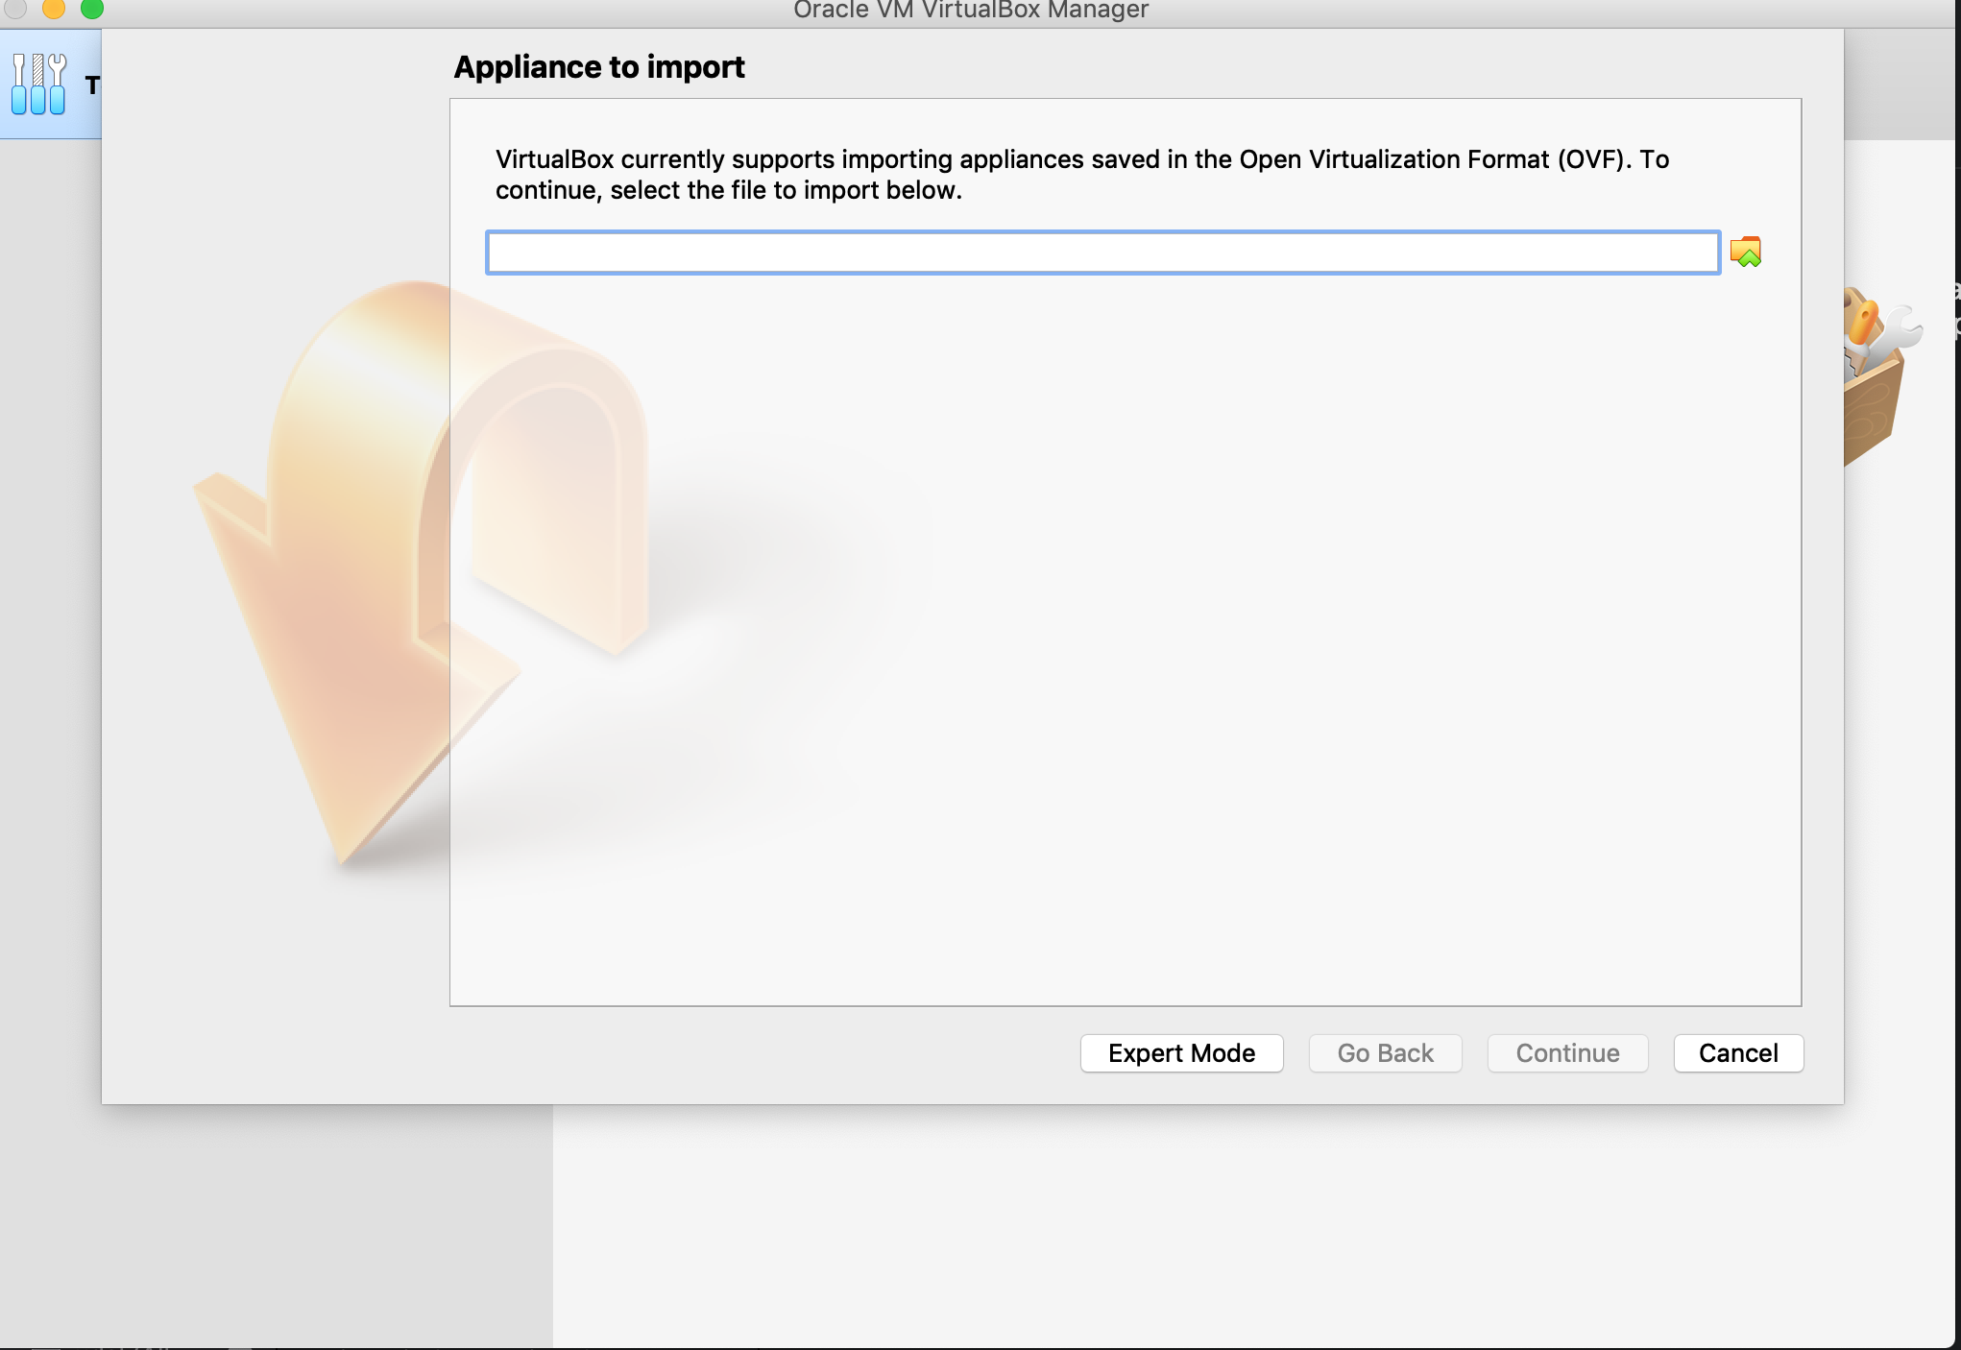

Next you navigate to where you put the math487.ova file is.

Select it and click open

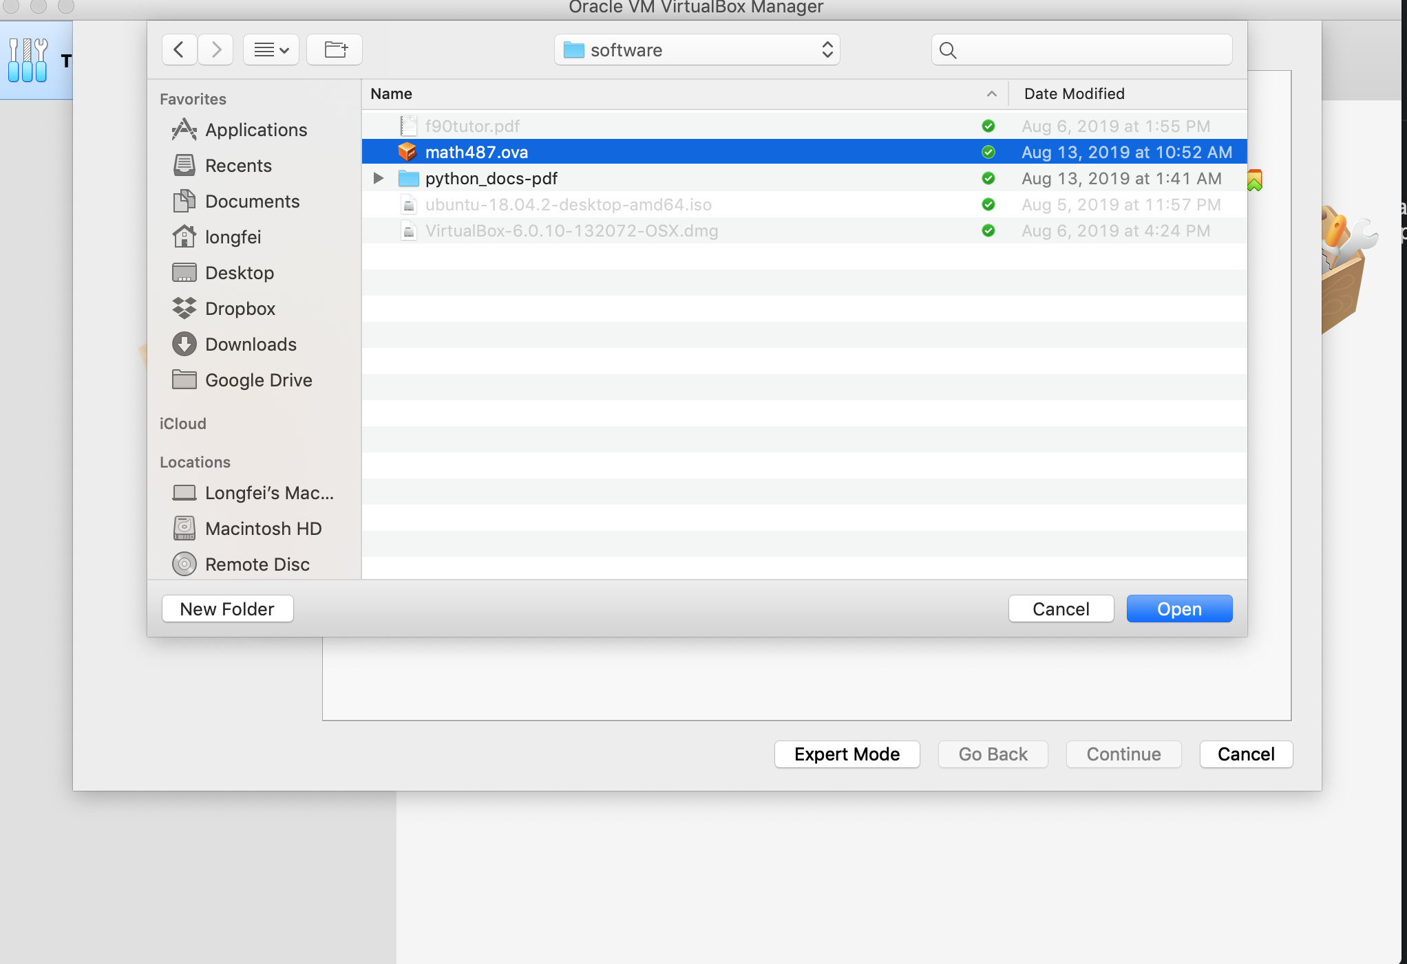

Then, you end up with the following screen, and click continue

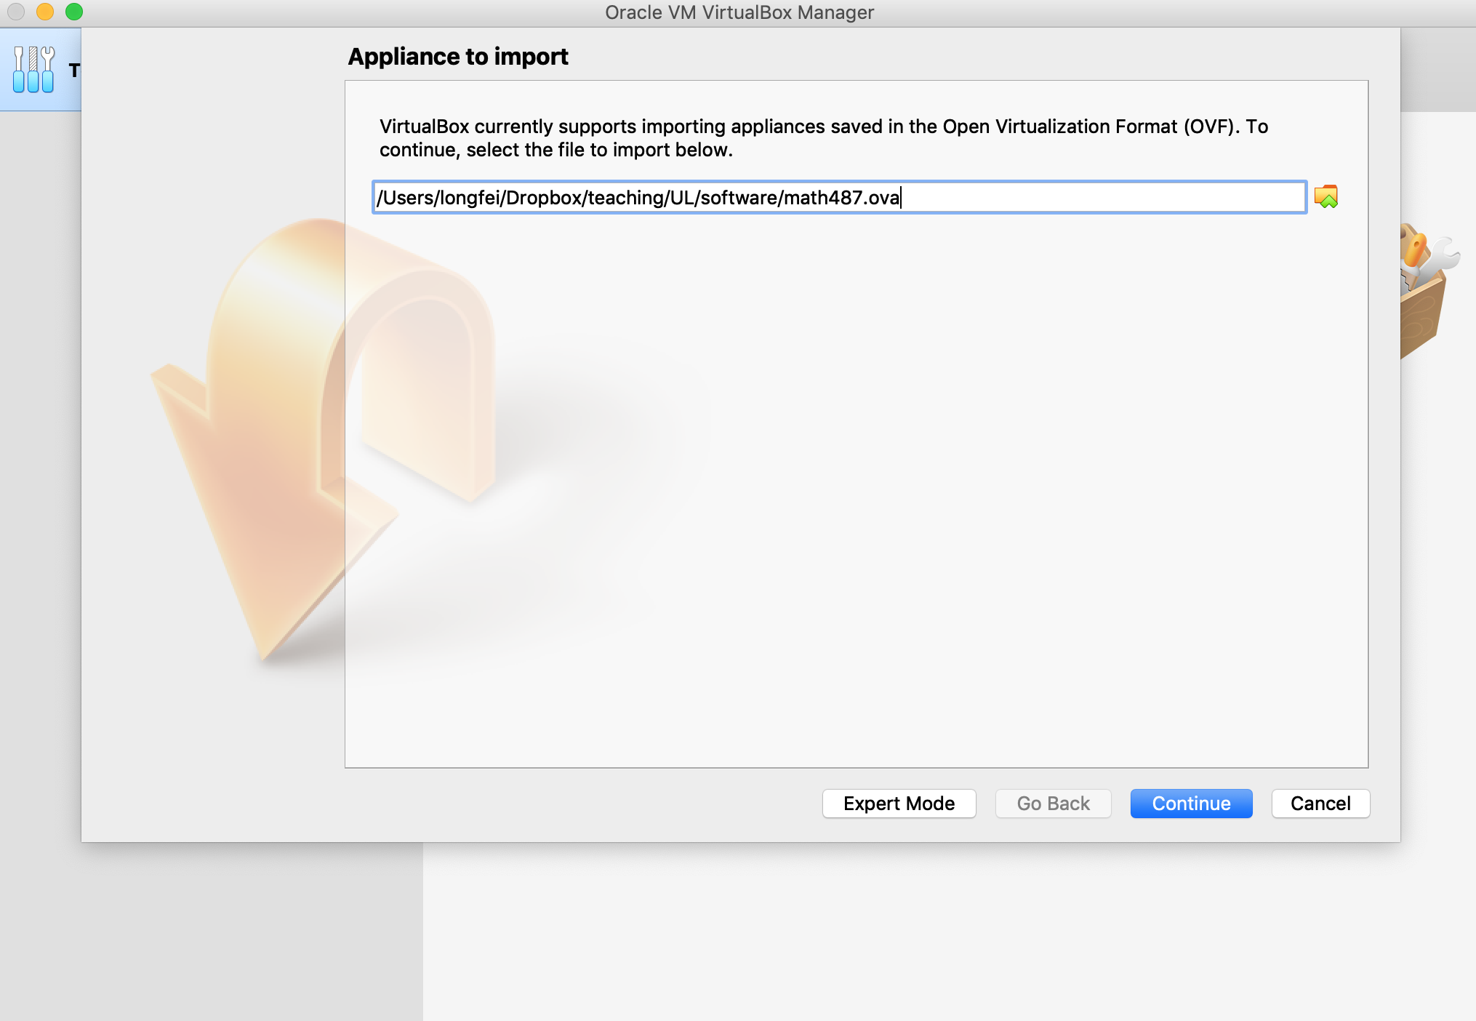

Next, click import

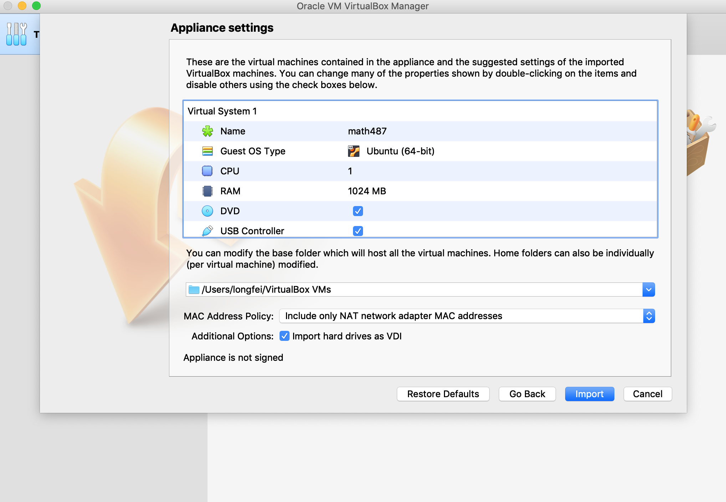

Next, wait a couple of minutes until the importation is done.

Now you have the mathe487 virtual machine (VM) imported on your computer, and you can use it for the class.

**How to Launch the VM**

1. After importation, every time you open the VirtualBox app, you will see this:

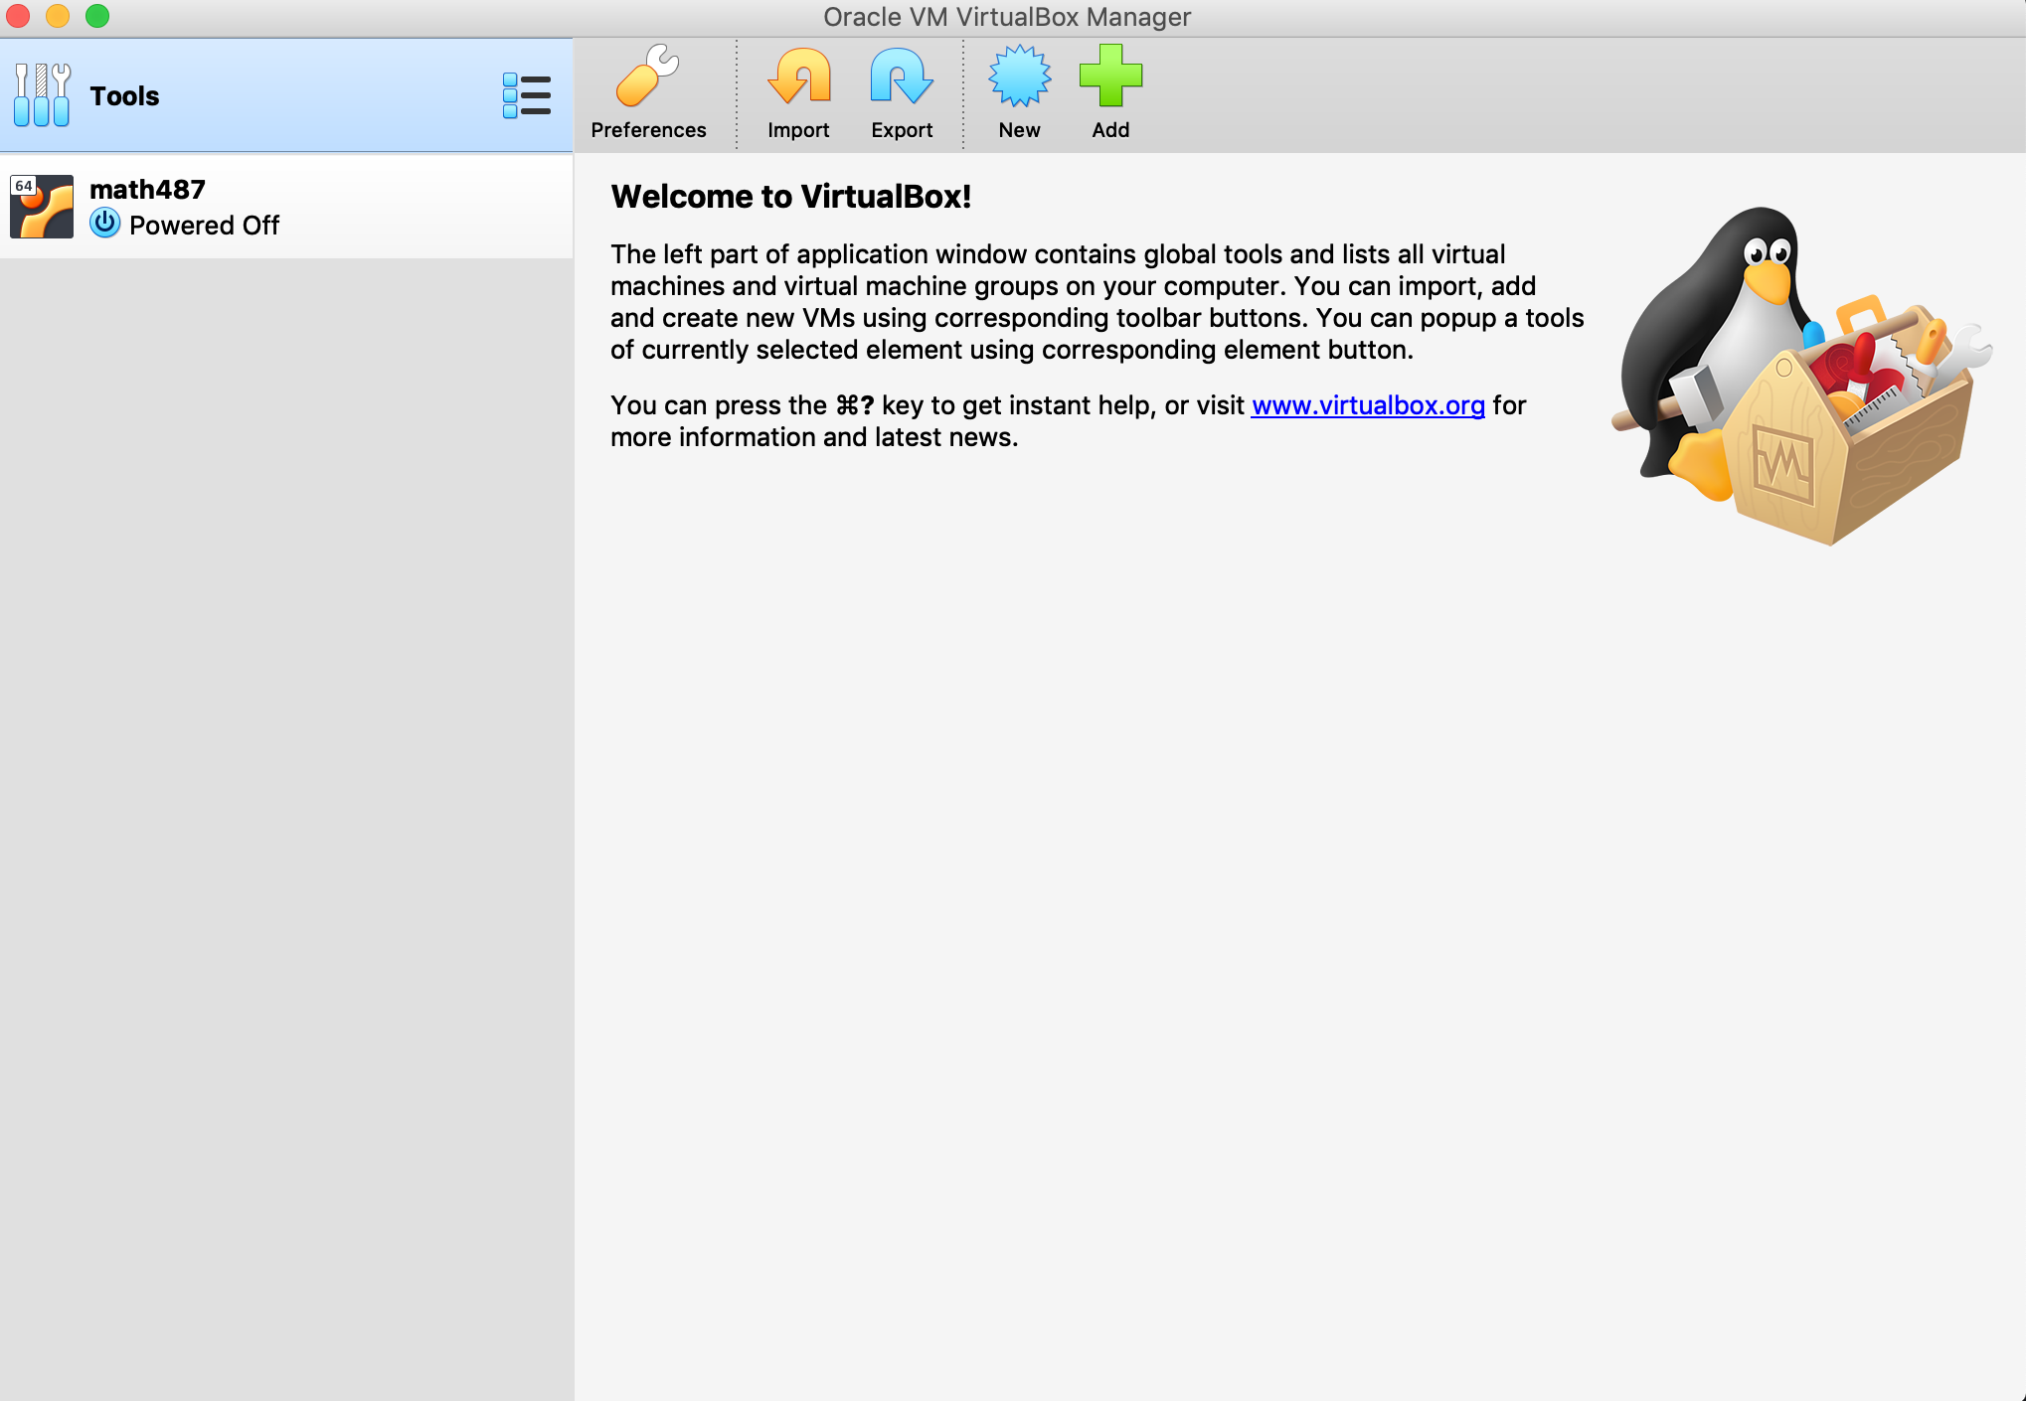

Double click this to Launch the math487 virtual machine

Next you will see

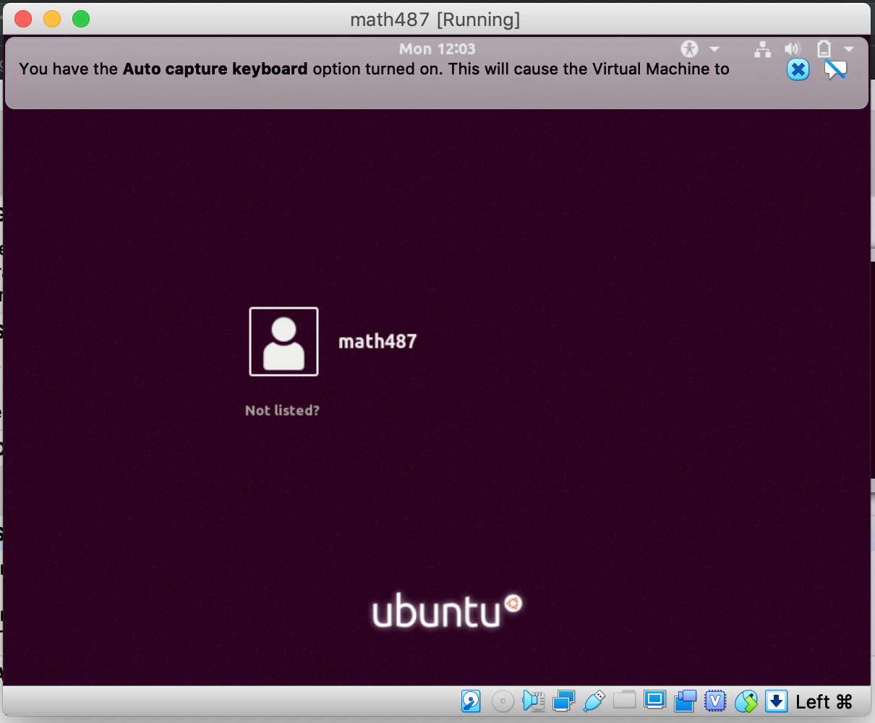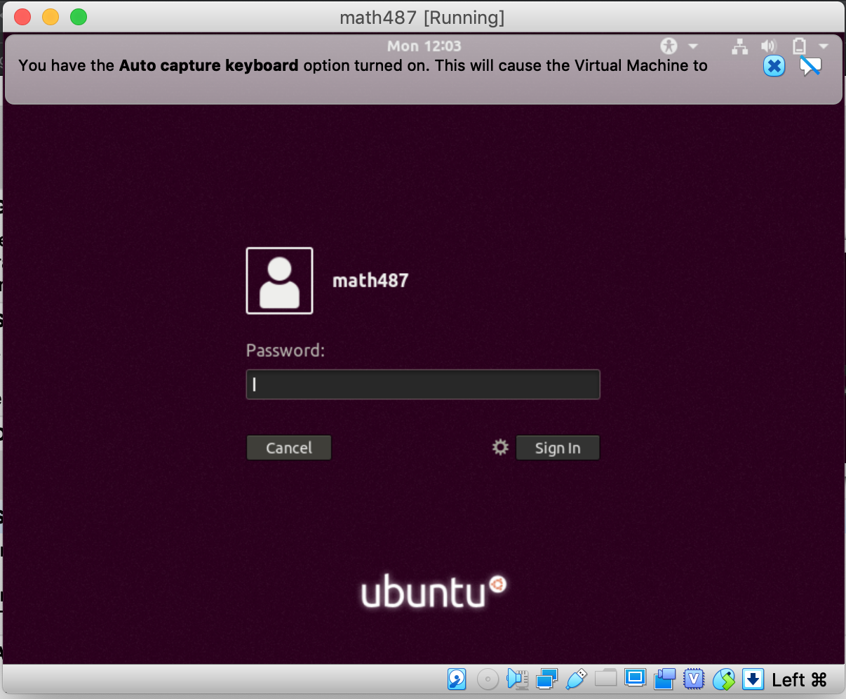

Password is: math487

Now you are running another computer from within your own computer:

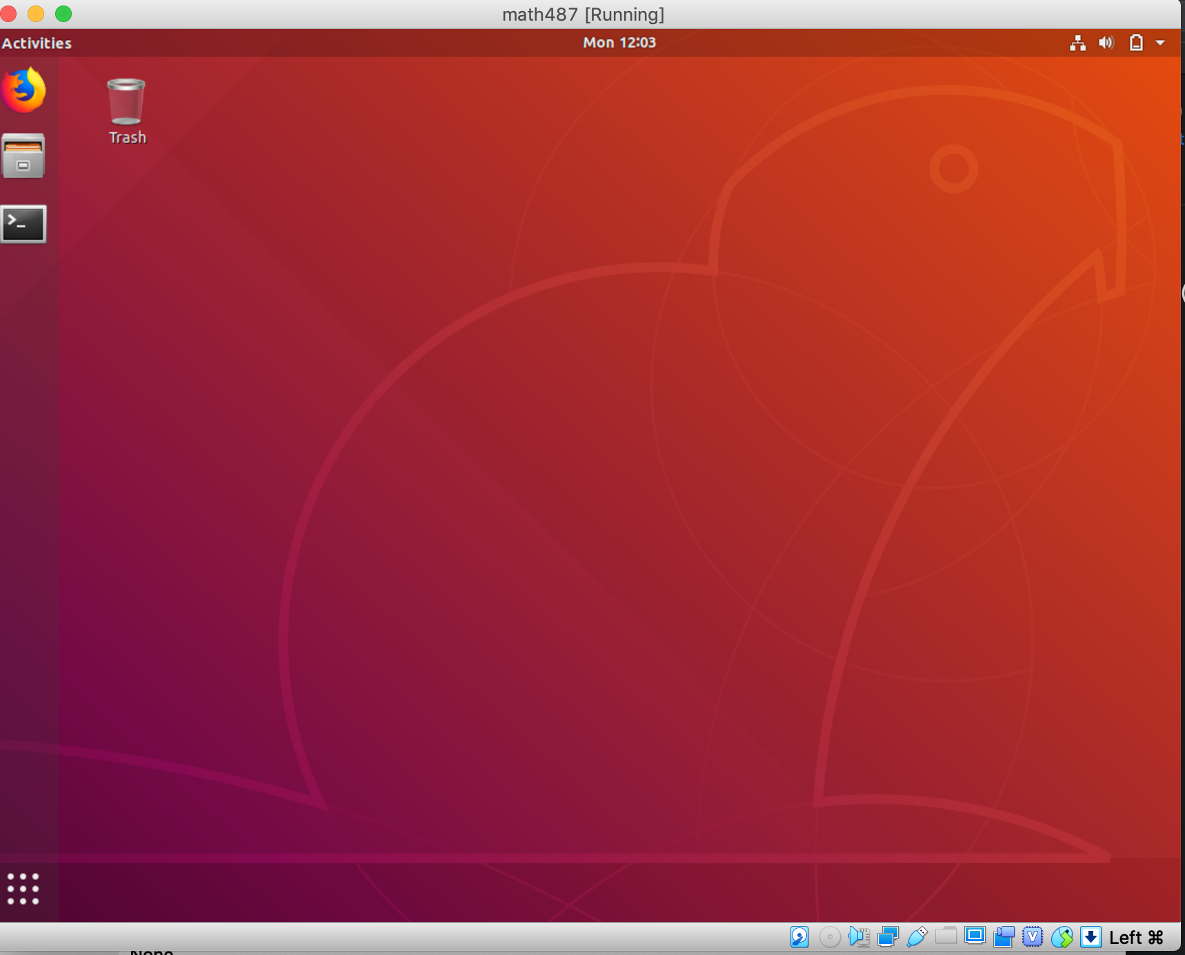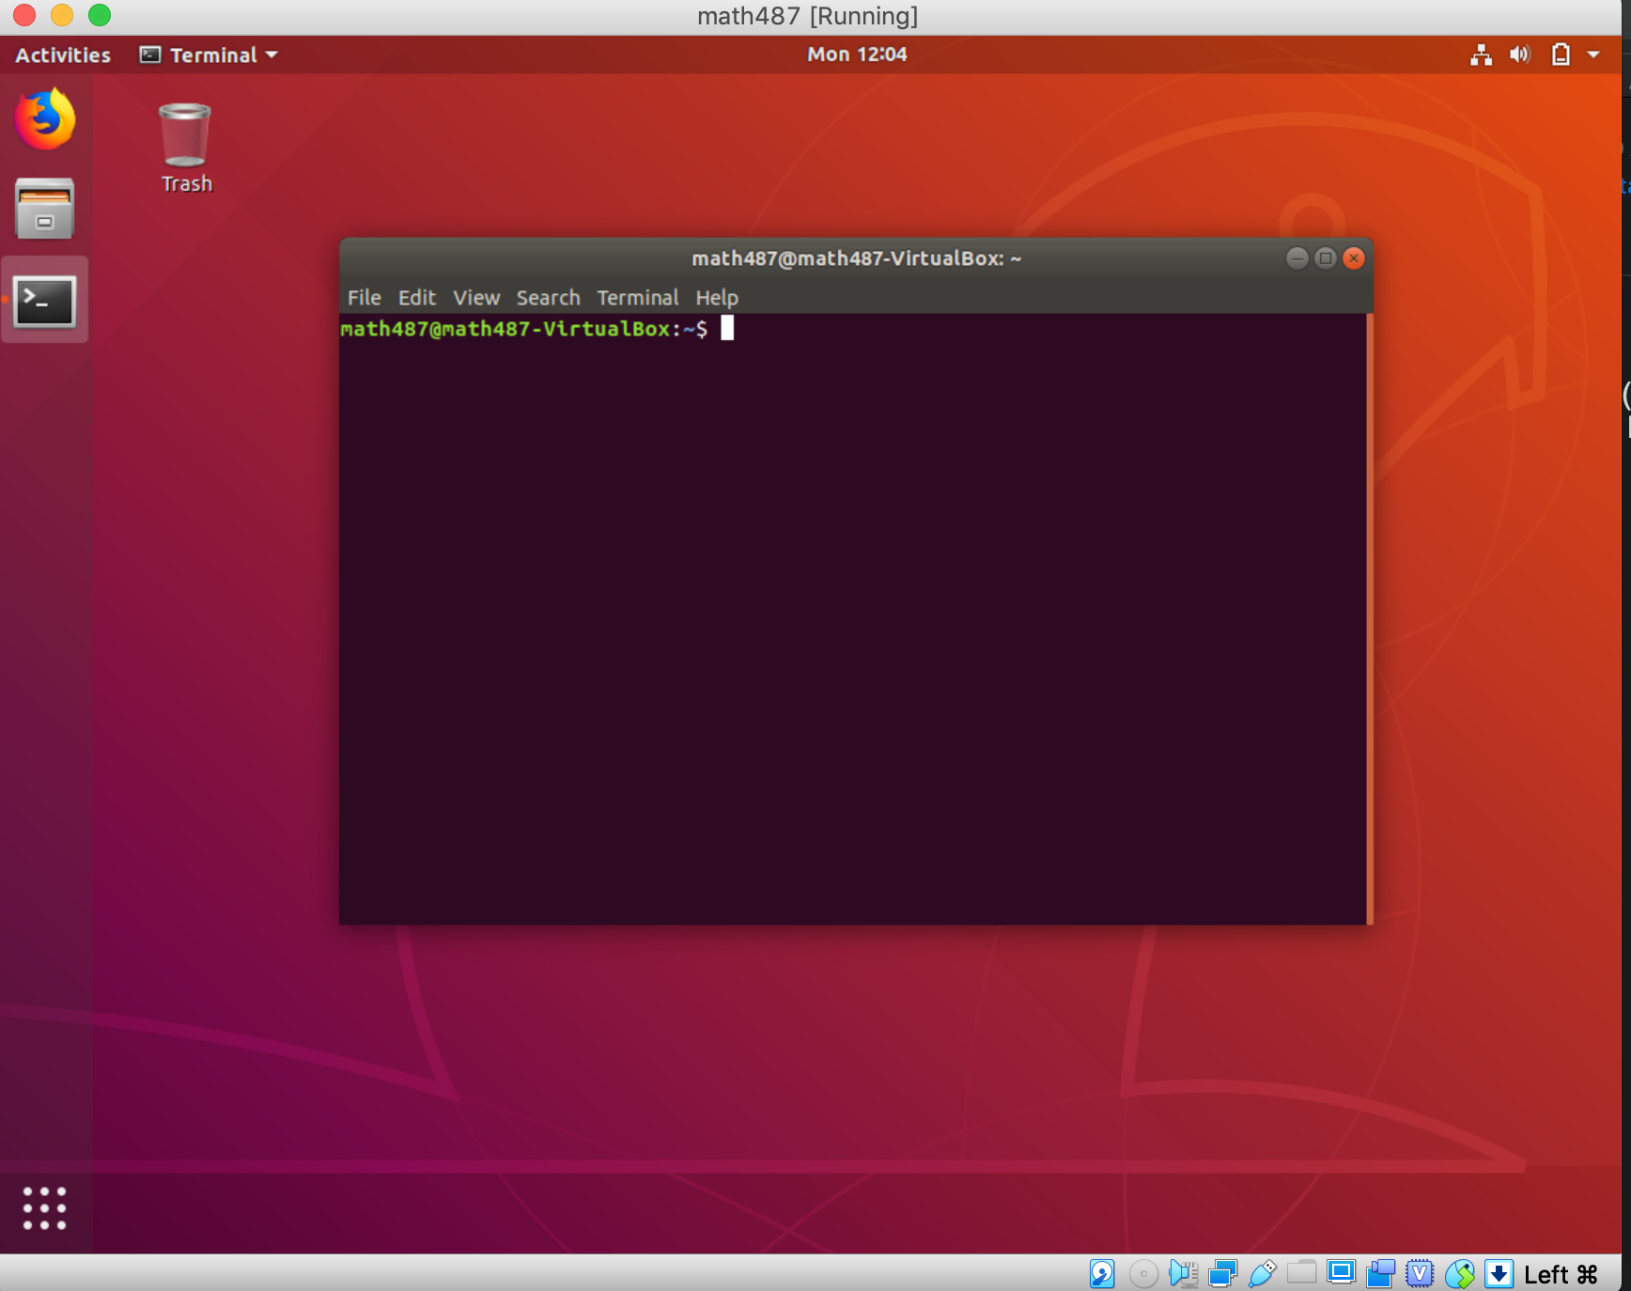

This is the terminal interface

Open the “terminal”

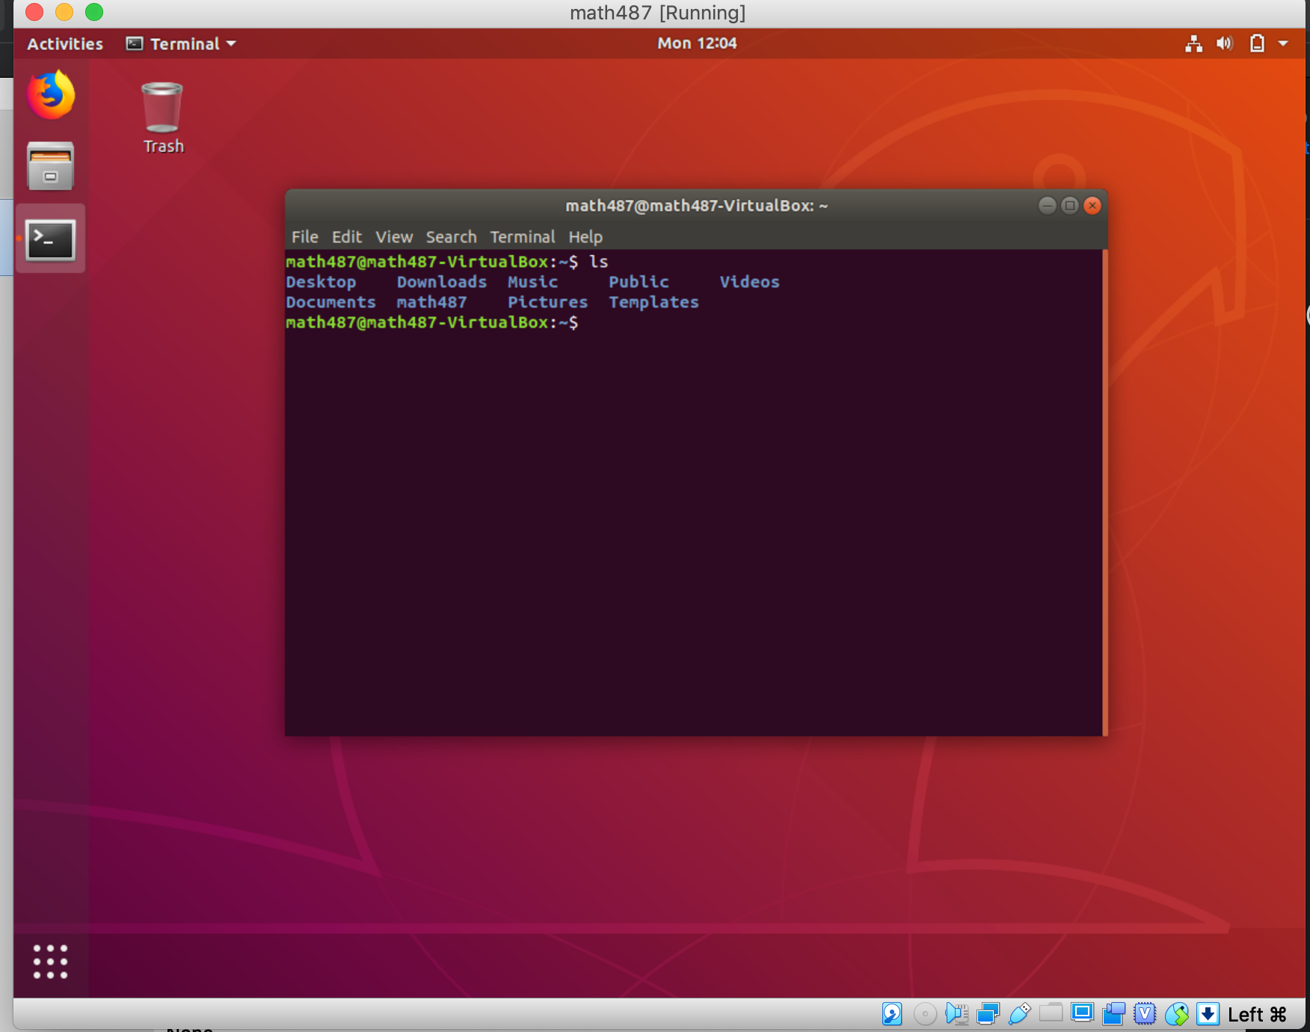

Now you can play around the various Linux command to navigate your “new” Linux computer